

**DBA5101 Analytics in Managerial Economics**

**Group Project 2**

The Effect of the Announcement of the Volcker Rule on the U.S Bank Holding Companies Responded to the Subprime Mortgage Crisis.

**Group 40 Members**

Chung YeonJong (A0280412R)

Lim Ciwen Brendan (A0216513N)

Matthieu Simon Bernard Zekhout (A0195691N)

Tey Ming Chuan (A0220997U)

**Introduction**

The Volcker Rule, a component of section 619 of the Dodd-Frank Wall Street Reform and Consumer Protection Act (DFA), was announced by the Obama administration in 2009 as a countermeasure to the risks of bank failures stemming from the 2007-2008 Financial Crisis. Implemented in 2010, this rule sought to restrict non-traditional banking activities, notably proprietary trading, and investments in hedge funds or private equities, with the overarching goal of bolstering systematic financial stability.

In this project, we want to assess the Volcker rule's impact on the bank's trading asset ratio, using panel data from multiple financial institutions over 2004-2015. We used propensity score matching to select our data. Then, we applied a Difference in Differences (DiD) model accounting for time and entity fixed effects and using financial indicators as control variables. This enabled us to assess the covariate balance for each control variable in treatment vs control. The fixed effects also allowed us to minimise endogeneity and baseline bias across time and between banks across different control variables. The results were then used to conclude the Volcker rule's effectiveness.

**Data Cleaning and Exploratory Data Analysis**

In the provided dataset, the panel dataset consists of 2473 banks across 40 unique quarterly periods. The dataset contains feature data that can be broken into the following categories:

* **Dependent Variable,** bhc_avgtradingratio: target column, trading asset ratio of banks is used to measure the effect of the Volcker Rule.
* **Dummy Variables**, after_DFA_1 and treat_3_b_avg: used to indicate whether a bank was in the treatment group and post-treatment period, respectively.
* **Control Variables**: These feature variables describe the status of financial indicators and different types of activities of the bank: *dep_roa1*, *dep_leverage*, *dep_lnassets*, *dep_creditrisk_total3*, *dep_cir*, *dep_depositratio*, *dep_loans_REratio*, *dep_liquidity*, *dep_cpp_bankquarter*

Additionally, there are 35 treatment banks of 2473 control banks across all periods, so our data sample is highly imbalanced. Notably, the target column, bhc_avgtradingratio, accounts for about half of its entries. Furthermore, some institutions have missing values for some of their control variables. We removed the rows with missing data altogether because we have no further information on those institutions (and using mean/median values to replace missing values could skew our results). We did not consider them in our analysis.

**Methodology**

We need to start our analysis by addressing the statistically significant differences between the treatment and control groups. We use propensity score matching (PSM) as mitigation to have a similar distribution of covariates across treatment and control groups. We first compute the propensity scores using logistic regression with treatment probability as the dependent and control variables as independent variables. The core idea is to estimate the probability of being treated (in this case, being affected by the Volcker Rule) based on observed characteristics. We then use 3-nearest neighbour matching to match treatment and control; comparisons for the resulting matched dataset can be found in Appendix 2.

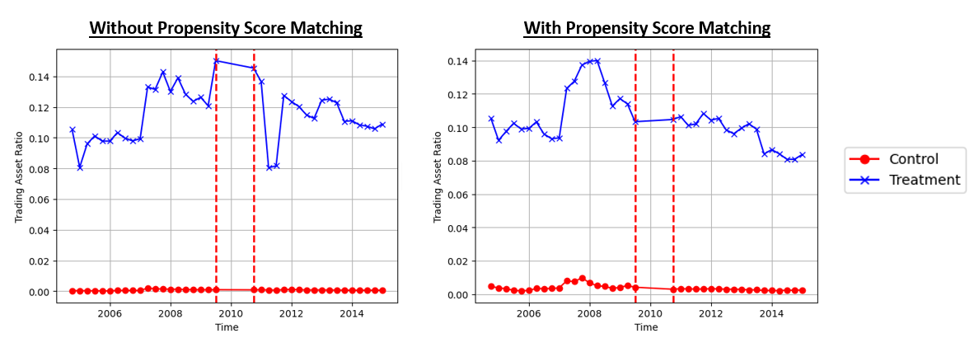

*Figure. 1 Visualising before and after Propensity score matching*

From Figure 1, we observe that the matched samples enable the control group to mimic some of the treatment group's behaviour, particularly from 2007 to 2009.

We can now run our DiD models using the equations below. We use linear regression with the average trading ratio of BHC as our dependent variable. Our independent variables include treatment/control, before/after treatment dummy variables, and the interaction between the two. We also include time and entity fixed effects to account for the variation of the trading asset ratio that we observe over time and that are not linked to treatment, as well as individual differences between the BHC. We also include our control variables to estimate treatment effects more precisely.

**With Fixed Effects:**

$$Y_{i,t}=β_{0}+ β_{1}*interaction+ X_{i,t}+γ_{i}+δ_{t}$$

**Without Fixed Effects:**

$Y_{i,t}=β_{0}+β_{1}*after_DF{A1}_{t} +β_{2}* treat_3_b_avg_{i}+β_{3}*interaction+ X_{i,t}$

*where $Y_{i,t}$ is the average trading asset ratio*

$X_{i,t}$*is the set of control variables*

$γ_{i}$*is the entity fixed effect*

$δ_{t}$*is the time fixed effect*

We run different variations of the model above to test for robustness. We aim to see a consistent coefficient pattern of interaction: We run the model over propensity-matched and total samples, including/excluding fixed effects.

**Results**

In total, 4 models were run, permuting with or without fixed effects and with or without propensity matching; the results are observed in Table 1 below. Comparing models with and without fixed effects shows that the fixed effects produce a much larger $β$ value and lower standard error. The larger $β$ reflects a larger DiD effect, and the lower error indicates higher estimate accuracy. Next, the propensity matching between Models 2 and 4 also increases the magnitude of $β$ and $R^{2 }$. Even though the standard error is shown to increase, matching is necessary, and it has previously been shown that matched samples are observed to have similar behaviours. **From Model 4, we can also conclude that the banks that initially had asset ratios above 3% did reduce their asset ratio by around 2.87%. We can thus conclude that the treatment (in this context, Volcker’s rule) was effective in getting banks to reduce their trading asset ratio.**

|  |  |  |  |  |
| --- | --- | --- | --- | --- |
|  | **Model 1** | **Model 2** | **Model 3** | **Model 4** |
| β **value** | 0.0037 ***  (0.0011) | -0.0234 ***  (0.0005) | -0.0150 **  (0.0050) | -0.0287 ***  (0.0029) |
| **R squared** | 0.5557 | 0.0532 | 0.6673 | 0.1780 |
| **Fixed effects** | NO | YES | NO | YES |
| **Propensity matching** | NO | NO | YES | YES |
| **Control variables** | YES | YES | YES | YES |
| **Observations** | 40026 | 40026 | 1061 | 1061 |

*Table 2. Model result comparison*

To consider the extent to which individual banks were affected by the rule, we choose to examine the magnitude of the coefficients of $γ_{i }$, where the larger the value, the higher its asset ratio compared to the benchmark. This is further generalisable that banks with the smallest values of $γ_{i }$, had the lowest asset ratios. Table 3 shows that the banks with the largest $γ_{i }$ (highest asset ratios) are all treatment banks, and those with the smallest values of $γ_{i }$ (lowest asset ratios) are all control banks. This shows that the DiD parameter of $β$ = -0.0287 applied to the banks with the largest asset ratios. Hence, the banks that reacted the most (treatment banks) have the largest asset ratios and reduced their asset ratios by about 2.87% more than those with low asset ratios.

|  |  |  |  |  |  |
| --- | --- | --- | --- | --- | --- |
| **Banks with highest asset ratio** | | | **Banks with lowest asset ratio** | | |
| **BHC** | γ | **treat_3_b_avg** | **BHC** | γ | **treat_3_b_avg** |
| 2797498 | 0.345901 | 1 | 1062528 | -0.116154 | 0 |
| 1039502 | 0.241778 | 1 | 1871159 | -0.094866 | 0 |
| 1951350 | 0.195829 | 1 | 1031449 | -0.094472 | 0 |
| 1073757 | 0.155891 | 1 | 1021879 | -0.088911 | 0 |
| 3232316 | 0.135855 | 1 | 1057850 | -0.077465 | 0 |

*Table 3. $γ$ coefficients for individual banks*

The model was progressively improved for robustness, firstly implementing individual and time-fixed effects to better account for variation. Next, propensity scoring was also done based on the control variables to ensure that the banks selected behaved similarly to each treatment bank to minimise the baseline bias.

We believe that the results obtained from Model 4 can inform banks and regulators alike. Firstly, individual fixed effects can enable regulators to better understand each bank while considering the time. Banks can also utilise the time-fixed effects to better understand how they fared during this period of economic uncertainty and how well they were adapting to the situation from their corporate strategy. From a regulator's point of view, however, this may not be a sufficiently in-depth study into how well the DFA helped to control banks' risk-taking behaviour against bank failure as we cannot quantify across the different types of assets and account for their volatility.

**Conclusion**

From our analysis, the banks that initially had higher trading asset ratios did reduce their trading assets after the announcement of the DFA. Banks with more than the regulated 3% asset ratio reduced their asset ratio by approximately 2.87%. From our model that calculates individual fixed effects, we can also segment which banks reacted more significantly than the others. Across the multiple models, we can reach similar conclusions, and hence, we are confident that the results are representative and statistically significant. From the parameters obtained, we further acknowledge that they can be used to advise banks and regulators alike. Still, this information needs to be further supplemented with additional sources to provide a holistic picture of the situation of bank risk.

**References**

Keppo, J., & Korte, J. (2018). Risk Targeting and Policy Illusions—Evidence from the Announcement of the Volcker Rule. *Management Science*, *64*(1), 215–234. Retrieved from: <https://doi.org/10.1287/mnsc.2016.2583>

Open AI, Chat GPT. Prompt obtained on 20 October 2023: <https://chat.openai.com/share/a3e0fdbc-49fb-4042-b785-7bd2e213b615>

**Appendices**

***Appendix 1: Bank Asset Trading Ratios, by Treatment or Control Group***

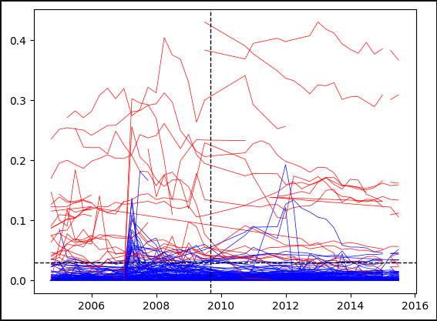

***Appendix 2: Propensity Matching Comparison***

Propensity matching allowed us to primarily reduce the discrepancy between the magnitude of assets. Once matching was done, we observed a reduction in the mean difference and an increase in the p-value for that variable.

While the p-value for a few other variables decreased, the matching allowed us to reject fewer coefficients in general. Before matching, only 5 variables passed the 0.05 p-value threshold, but matching increased the number to 6 variables. Combined with the visualisation from Figure 1, we are more confident that the matched samples better represent the probability of being sampled.

|  |  |  |  |  |  |  |
| --- | --- | --- | --- | --- | --- | --- |
| **Variable** | **Standard** | | **Propensity matched** | | **Comparison** | |
| **Mean** | **P value** | **Mean** | **P value** | **Mean Reduction** | **P value reduction** |
| **dep_lnassets** | -4.42319 | 0.00 | -1.89362 | 0.154157 | 2.529561 | 0.15 |
| **dep_leverage** | -0.00366 | 0.17 | 0.014412 | 0.005643 | 0.018069 | -0.16 |
| **dep_roa1** | -0.00021 | 0.83 | 0.00149 | 0.650419 | 0.001703 | -0.18 |
| **dep_liquidity** | -0.03528 | 0.24 | 0.016466 | 0.14831 | 0.051747 | -0.09 |
| **dep_depositratio** | 0.36005 | 0.00 | 0.144117 | 0.820534 | -0.21593 | 0.82 |
| **dep_loans_REratio** | 0.336637 | 0.00 | 0.034249 | 0.854638 | -0.30239 | 0.85 |
| **dep_cir** | -0.06209 | 0.32 | -0.00171 | 0.001272 | 0.060376 | -0.32 |
| **dep_creditrisk_total3** | 0.002128 | 0.43 | -0.00853 | 0.058628 | -0.01066 | -0.38 |
| **dep_cpp_bankquarter** | 0.002305 | NA | -0.00852 | NA | -0.01083 | NA |

***Appendix 3: GitHub code***

* GitHub URL: <https://github.com/mariotey/DBA5101/tree/main/Project2>